Locating Riyadh Residential Areas which lack for Public Library using

Spatial Statistics Analysis and Network Analysis

The Goal from this Project is to help to locate which residential areas in my city lack for Public Library within 20 minutes drive, this is very accurate methodology not same as BUFFER , The BUFFER take Radius that you defined and based on distance not time! but in this analysis I will use the Service Area Network Analysis which will distribute along the residential areas and cover it completely

And calculate the approx. time needed to reach to library but First , I will use Spatial Statistics Tools to help me Identify the Phenomena which in this case: the libraries , I will use The Mean Center Tool to identify the exact spot for the center of the Libraries see Fig(1). In this Case it is (Jarir Bookstore in Olaya) is the mean center for all the libraries.

صورة تحتوي على نص, خريطة, أطلس, لقطة شاشة

تم إنشاء الوصف تلقائياً

Fig(1) Mean Center tool

Next I will use Standard Distance tool , This tools draws circle around the Mean Center to know the spread of the phenomena (the libraries) and see is it too much or little. See Fig(2)

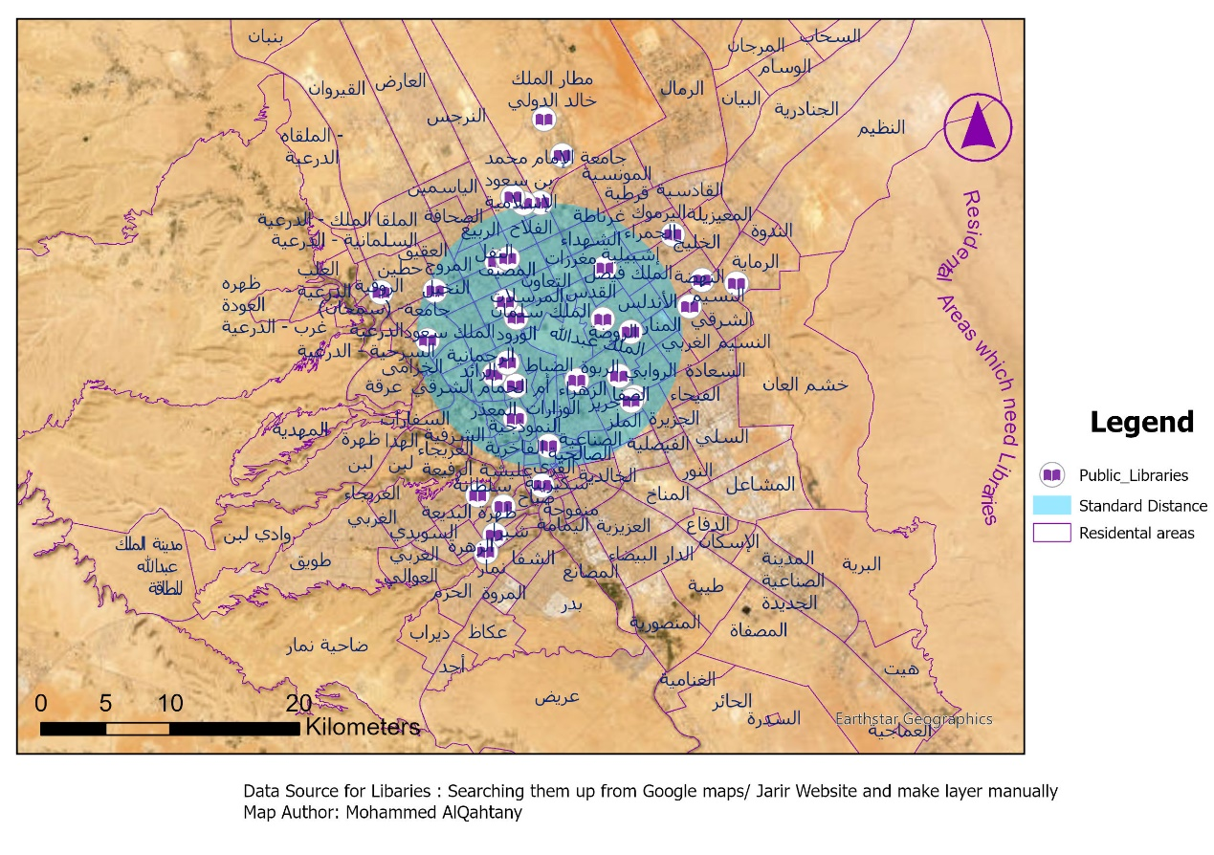

Next I will use the Directional Distribution Tool to help me understand the direction this phenomena is going to . see fig(3)

Fig(2) Standard Distance tool

صورة تحتوي على نص, خريطة, أطلس, لقطة شاشة

تم إنشاء الوصف تلقائياً

Fig(3) Directional Distribution of Libraries

It Distributes towards NE with 15 degrees .

2)Network Analysis : Service Area to find the areas lack for libraries based on 20 minutes driving time, This Precise Analysis Requires Road Layer with Very important Attributes like Road Length and Road Speed etc. I couldn't get this Layer so I used ESRI International Road System , This System is very Accurate and requires license and credits to use it

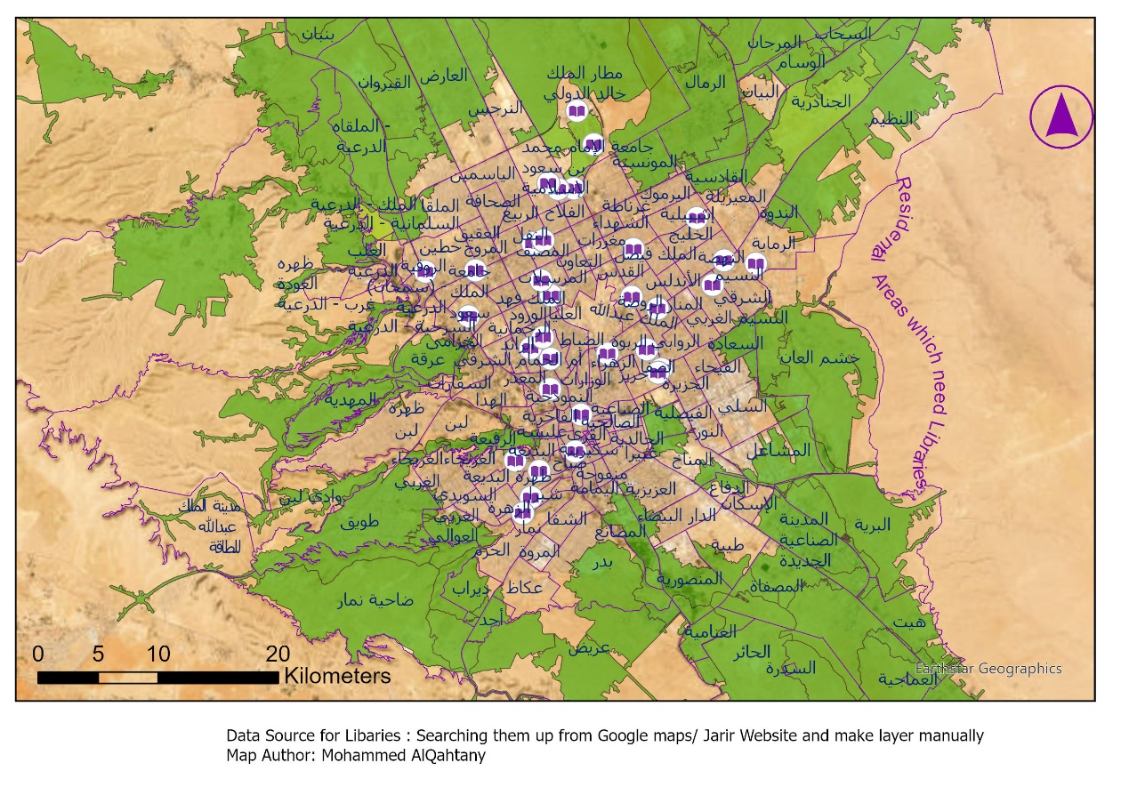

We Can See in figure (4) from Service Area Analysis The Green Colored Regions are the areas which Require 20 or above minutes driving time to reach to Libraries, Hence they need libraries for their own!

See the Attribute Tables below for more information about the libraries:

Attribute Tables for Libraries which I Google them and use Jarir Book store website in my analysis:

صورة تحتوي على نص, لقطة شاشة, رقم, الخط

تم إنشاء الوصف تلقائياً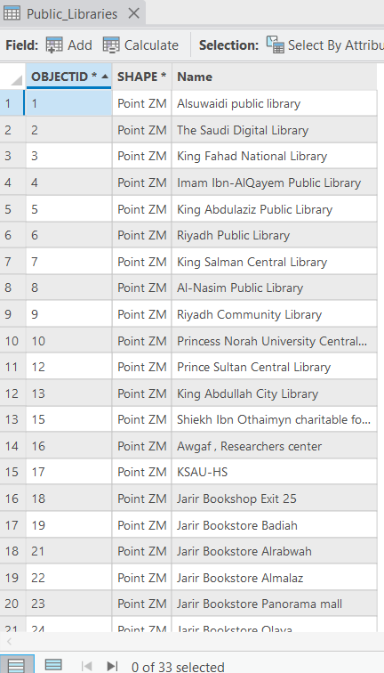

My Recommendations are:

-Build More Public Libraries in the Areas lack for libraries, As this analysis clearly shows how lack we are for public libraries